|  |  |
| --- | --- |
| **STUDENT PORTFOLIO** | |
|  | **Name: Nitin Nagar**  **Register Number: RA2111003010868**  **Mail ID: na6187@srmist.edu.in**  **Department: B.Tech**  **Specialization: CSE**  **Semester: 3** |
| **Subject Title: 18CSC201J Data Structures and Algorithms**  **Handled By: Sindhu C** | |
| **Assignment – CrossWord Puzzle (Unit 1,2,3, & 4)**  The assignment questions were distinctive and designed to evaluate each student's understanding of DSA. The teachers made a valiant effort. I found it beneficial to push myself in these data structures-related areas. It aided me in reviewing the majority of crucial data structure’s themes. With the help of my knowledge and the lectures that our lecturer had taught us, I was able to answer these questions. And as I worked through these problems, I made sure to use all of the available hints and hints and clues. | |
| **Assignment**  The assignment increased my understanding of the topic and helped me to complete more problems based on the topic. | |
| **Codechef Achievements**  Completed all Assignments assigned by the faculty | |
| **Any other**  Hackerrank Badge in C++ Programming  Completed C Programming in E-LAB | |
|  | |

|  |  |  |  |  |  |  |  |  |  |  |  |  |  |  |  |
| --- | --- | --- | --- | --- | --- | --- | --- | --- | --- | --- | --- | --- | --- | --- | --- |
|  | **Signature** | | | | | | | | | | | | |  | |
|  |  | |
|  |  | |
|  |  | |
|  |  | |
|  |  | |
|  |  | |
|  |  | |
|  |  |  |  |  |  |  |  |  |  |  |  |  |  | |
| **Note: Enclose the assignment and relevant certificates along with the profile** | | | | | | | | | | | | | | | |

**CROSSWORD QUESTIONS SNAPSHOTS**

**UNIT-1 CROSSWORD**

**UNIT 2 CROSSWORD**

D

UNIT-3 CROSSWORD

UNIT-4 CROSSWORD

CODECHEF PROFILE

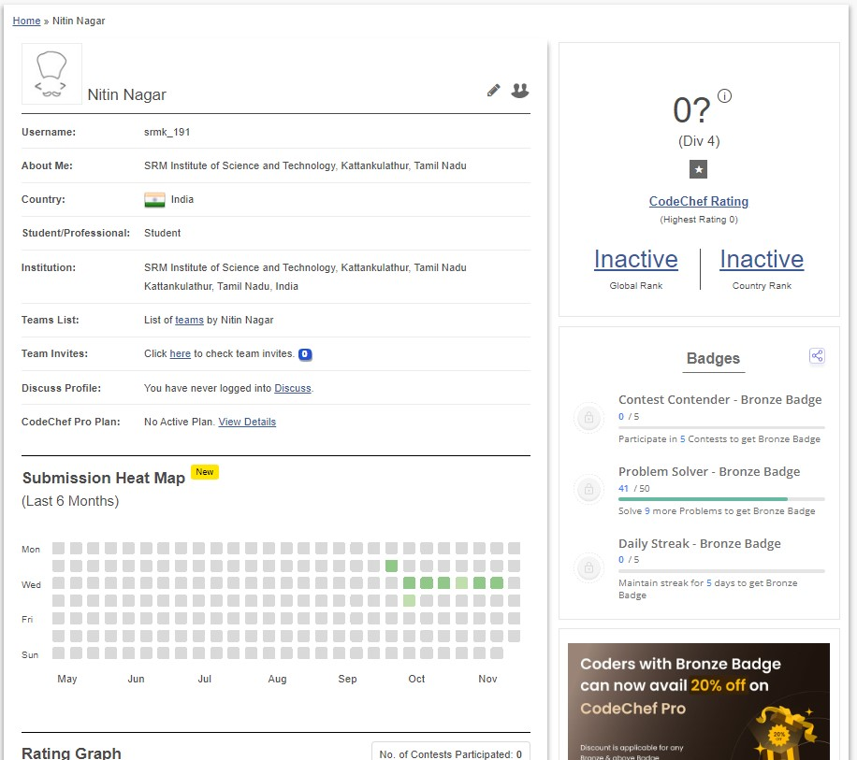

HACKERRANK PROFILE

